THE ARCTIC STAR MEDAL
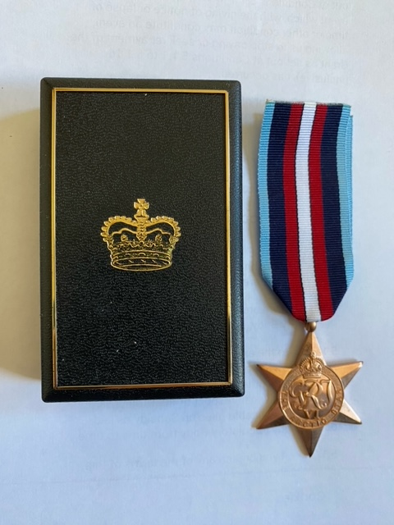 | 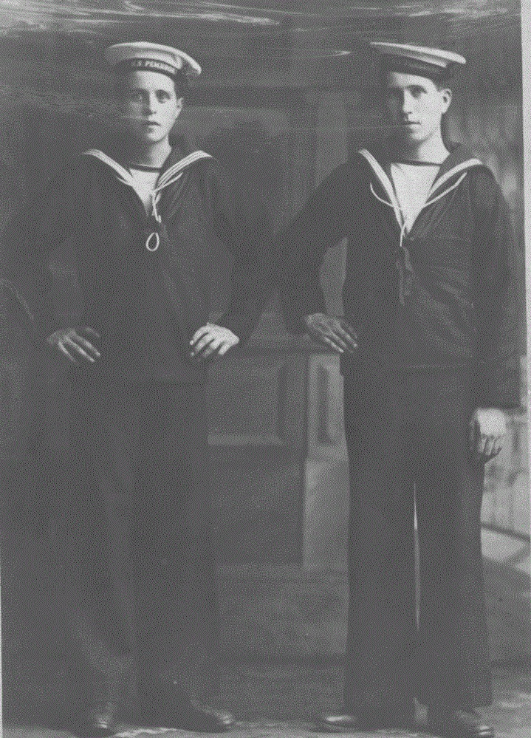

Above: my father & his brother John. Royal Navy Reserve cadets circa early 1920s.
Below: my father’s Royal Navy service record covering the years of WW2

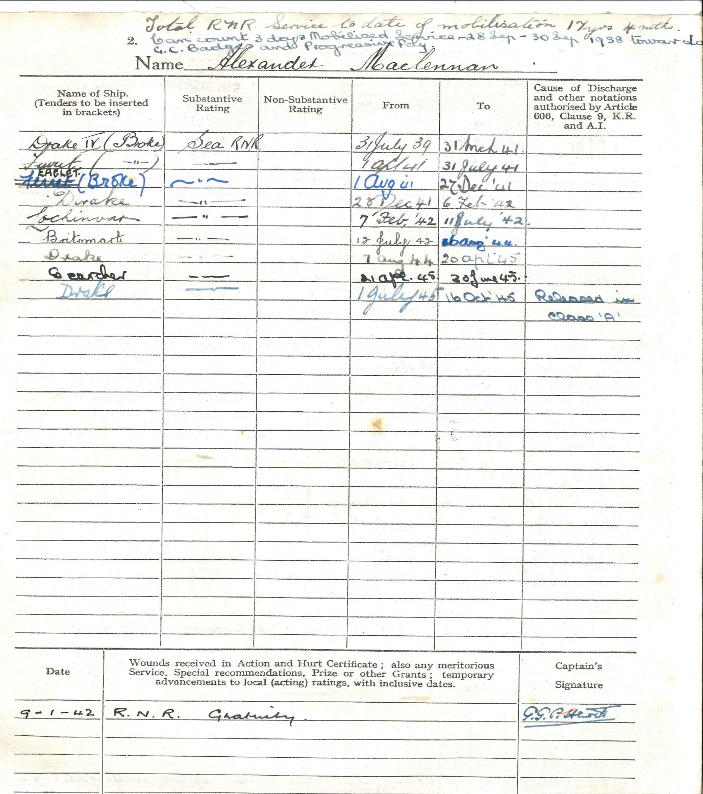
My father, Alexander Maclennan, Seaman AB, Royal Navy Official No D5690, served in the Royal Navy during WW2 from July 1939 until July 1945.

He served as quartermaster ( helmsman ) on all his naval vessels due to his experience in the Merchant Navy during 17 years at sea prior to the War.

He was born in Garenin in 1904 (Isle of Lewis) but he and his family moved to Dalmore around 1923.

Psalms 107:23-31 King James Version

“They that go down to the sea in ships, That do business in great waters; These see the works of the LORD, And his wonders in the deep. For he commandeth, and raiseth the stormy wind, Which lifteth up the waves thereof.”

Royal Naval Reserve (RNR)
My father joined the Royal Naval Reserve (RNR) early in his late teens . He regularly attended the Battery in Stornoway where he and others received RNR training in seamanship and once a year he would receive advanced training at a RN shore base in England taking 1/2 weeks . Travel expenses were paid and an annual bonus paid, which was appreciated by the young RN lads from Lewis.
The outbreak of the war with Germany (later WW2) was declared by Britain on 3 September 1939 , but my father was called up by the RN on 31 July 1939 . RNR men were always called up first in the event of war or some other serious conflict.
He joined the naval destroyer, HMS Broke on 31 July 1939 .
At this point I should inform readers that my father was wont to repeat phrases as they tumbled into his consciousness and why as children we knew not why. The following I remember well.
Lord Roberts of Kandahar
Lord Gordon of Khartoum
Lord Evans of the Broke.
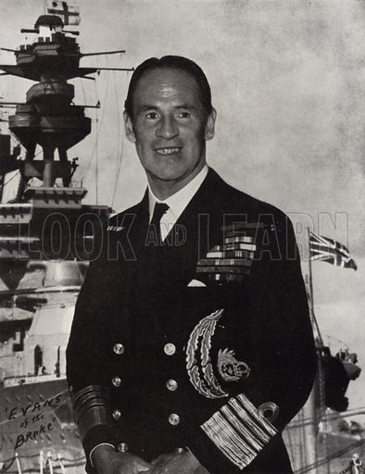
Evans of The Broke
I don’t think he was ever in Kandahar or Khartoum, but he was on the Broke, for sure.
HMS Broke
There were three RN vessels named HMS Broke.
1. A cutter hired by the RN in 1814 ( Napoleonic wars ).
2. A Faulkner Class flotilla leader, launched in May 1914
3. A Thornycroft type destroyer leader. Major refit in Devonport in 1936/37 and returned to duties in the Channel as an emergency destroyer. This was the HMS Broke which my father joined on 31 July , 1939 , his very first RN vessel-a destroyer.
The Broke weighed 1600 tons , 329 feet in length, top speed 42 mph and had a complement of 164 persons.
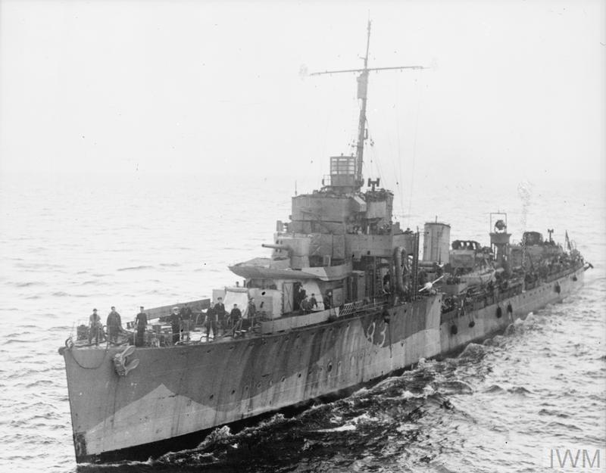
HMS Broke

My father , as a quartermaster on board the Broke, had an interesting and exciting initiation to life on board a destroyer of the King’s Navy. As can be seen , the vessel was to take on various operations.
September 1939, the Broke was deployed on convoy service in the North Sea.

- October ‘39, the Broke was transferred to the Western Approaches Command ( Atlantic) for convoy defence and submarine patrol. These duties continued in the Atlantic until January’40.

- January 13th , 1940, the Broke joined Convoy HG15F as an escort from Liverpool in home waters.
- March ‘40 escorted convoys to and from Plymouth and Gibraltar ( of short duration).

- 12th April ‘40. HMS Broke was detached from convoy duty to continue in home waters.

My father left the Broke but would re-join the destroyer two weeks later after attending courses in seamanship and particular aspects of required training in naval warfare.
These occurred mainly at Shore Bases in the U.K. from 14 April 1940 until 26 April.
These home bases carry the designation HMS as naval regulations in them are the same as aboard a vessel at sea . The four bases where training took place were:
HMS Drake , Sandhurst , Cochrane, Orlando.

While on duty as quartermaster on board the destroyer HMS Broke, my father was aware of a young naval officer, lieutenant Scott on the bridge beside him. He discovered that this young man had well-known connections. This was Peter Scott, the son of the famed Antarctic explorer, Robert Falcon Scott, who with others died there after reaching the South Poll, but after Amundsen had reached the Pole before him. Edward Evans “of the Broke “whose name seemed familiar to my father, was second-in-command on Robert Falcon Scott’s expedition to the South Pole in 1910-1913
He accompanied Scott to within 150 miles of the Pole but was ordered back in command of the last supporting party. He narrowly survived as he was seriously ill with scurvy .He had an illustrious career back in the RN and was decorated many times. He rose to the rank of Admiral.
The moniker “Evans of the Broke” was given to him after captaining the destroyer Broke at the Battle of Dover Straits in 1917.

Sir Peter Markham Scott

Peter Scott studied fine arts at Cambridge and continued his art studies in pre-war Germany . On his return to the U.K. he had a successful career in the art world with paintings, books and reproductions. For this reason, Peter Scott arrived at HMS Broke in 1940 to experiment with various forms of camouflage which would be painted on the hulls of RN warships. The Broke was the first vessel chosen for this experiment. The form of camouflage used was known as “dazzle” which involved painting each side of ships’ hulls differently and in various geometric shapes and in differing shades of black and white.
The theory was that this would confuse the German warships, particularly the U-boats, in determining the speed and direction of British naval vessels.

Around 1960 , things were stirring in the Maclennan house in Renfrew. My father was dressing in his number ones and my mother was perplexed, this being the late afternoon when her husband would normally be asleep in his easy chair. She just had to ask. “ Where are you going all dressed up like that ?”
In answer, my father said. “ I am going to the St.Andrews Hall in Glasgow to see Sir Peter Scott , who Is giving a talk on birds.” My mother was still perplexed.

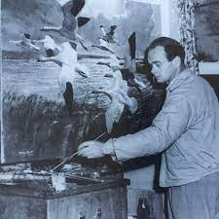

Sir Peter Scott

My father slept through all of Sir Peter’s lecture and heard nothing of mallard nor the greylag geese.
He was gently roused by a kindly commissionaire to say that the hall would be closing. Indicating that he had come to see Sir Peter Scott, my father followed his ‘guide’ down a long corridor stopping at a particular dressing room . As Sir Peter emerged, mention was made of the HMS Broke, the man at the wheel and much more. A cordial conversation ensued and Sir Peter was very glad to meet a fellow sailor again, and Big Alex returned home happy, with a great story to tell.

HMS Tuscaloosa

Following a period of training at various home bases , the longest being at HMS Lochinver for training in minesweepers , the 9th August 1942 , my father’s naval record shows him aboard HMS Tuscaloosa
a name which did not seem to belong to the likes of Cochrane or Drake. The internet said that this was in fact the USS Tuscaloosa operating with the British Home Fleet, under Roosevelt’s lend -lease scheme which began after Pearl Harbour, when the US entered WW2 (7 Dec 1941)
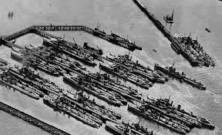
HMS Lochinver, South Queensferry
This was a large heavy cruiser, commissioned in 1934 , operating in the European theatre during 1942-1944. She dropped anchor in Scapa Flow in April 1942 to receive orders . This was a modern heavily armed
warship with a complement of nearly 1800 men aboard.

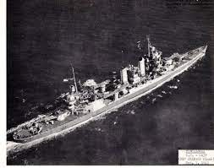
HMS Tuscaloosa
In the European theatre the cruiser was involved in convoy protection, first carrier strikes in Norway, D-Day, South of France and North Africa. What my father was doing aboard this US cruiser from 10.8.42 - 23.8.42 ( only 14 days ) , I have no idea, except that he was a very experienced helmsman.
After 1944, now reverting to its original designation, the USS Tuscaloosa did great work in the Pacific at Iwo Jima and Okinawa . The vessel was awarded 7 Stars by the US Admiralty for its record during WW2.

HMS Salamander

After a mere 14 days on the HMS Tuscaloosa , my father was transferred to the HMS Salamander for a stay of only 2 days on 24/25 August 1942. This vessel was a Halcyon Class minesweeper,
launched on 24 March 1936.

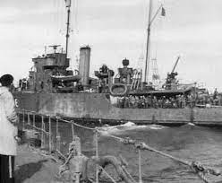
HMS Salamander
My father’s short stay on the Salamander could only have been to acquaint him with his requirements as a helmsman on board a British minesweeper. From its launch, quite a few things were to plague this ship and it returned many times for refits at south coast naval yards . I presume all was ‘ship shape’ for my father’s short visit on the Salamander.
On the day after my father left the ship ie. 26 Aug.1946, a terrible disaster was to visit the Salamander in the English Channel. From behind the clouds an RAF Typhoon along with two Spitfires of the Polish Air Force attacked the Salamander leaving it little time to defend itself. The rear of the ship was completely destroyed from a missile from the Typhoon. 11 of the crew were injured, 5 seriously. This cockup was, even in these days, designated as ‘friendly fire’. I presume that the Salamander was out of action for the duration.

HMS Britomart

What follows is the two years that my dad was aboard the HMS Britomart, a British minesweeper of the Halcyon Class which together with other minesweepers operated in flotillas in the North Russian seas.

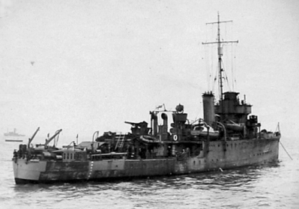
HMS Britomart 1942

There will be many parts of the story covering two years of perilous times, but clearly remembered by father.
The Russian Convoys in the 1940s bore code names such as PQ12 ,where the P indicated the date and departure port in the U.K. for for Russian destinations. The letter Q showed the reverse sailing of that convoy to the U.K. The number showed the order of sailings of these Russian convoys . The lead ships in convoys were termed ‘flotilla’ and were of various sizes and always of the same vessels. My father‘s vessel was of the Halcyon Class minesweeper which, of size 7,say, would be in a reverse V-formation , with a lead minesweeper at its apex (commander i.c.) and two arms of three vessels making up the flotilla. On very long drawn out convoys, these flotillas would include heavily armed vessels like destroyers, or carriers which was the case with the disastrous convoy PQ 17 which was destroyed in the seas off Norway and the Barents Sea in Russian waters.
My father joined the Britomart on 26 August 1942 to take part on his first Russian convoy, exactly two months after the PQ 17 was destroyed due to grave errors of communication emanating from the Admiralty in U.K.
The convoy PQ 17 left its departure port on 27 June 1942 and met its end 10 July 1942 when they were ordered to ‘scatter’ , the warships to the west leaving the merchant ships to make for North Russian ports such as Murmansk. They were sitting ducks for the Nazi warships, the Luftwaffe and the U-boats. I am glad my father was on a later convoy, as I would not have known this fine gentleman.

The Allied convoys to North Russia in WW2 came about in the way best described below.

Molotov-Ribbentrop Pact & Operation Barbarossa

Signed in Moscow on 23 August 1939. This was a treaty of nonaggression between Nazi Germany and Russia, planned to expire on 23 August 1949. It lasted 22 months and had governments the world over left in abject disbelief.
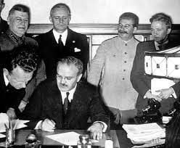
“Best of Enemies” – Signing of the Molotov-Ribbentrop Pact
The pact defined their spheres of influence across Poland, Finland, Lithuania, Estonia and Latvia. They had differing reasons for what they could make of the pact, especially Germany’s desire for ‘a foot’ in Poland. For the first 18 months, Germany gained economically from the arrangement and could access grain and oil from the USSR . Russia was interested in the manufactured goods which Germany could provide.
Hitler thought he could make his move on invading Russia ( Operation Barbarossa ) during 22 June ‘41 until their defeat in the snows of 7 Jan ‘42 .

The Arctic Convoys
While the Nazis were increasingly tied up in war in Russia, Stalin ( in a new pact ) demanded help from his new allies in armaments and machine parts. They could only be sent via convoys to the north Russian ports of Archangel and Murmansk a long way in very cold and fierce seas. During this period ( last 6 months ‘41 until early ‘42 ) convoys despatched from U.K. ports had a very high record of success until Germany decided to act against Allied convoys making their way to North Russia in Norway waters and the Barents Sea .
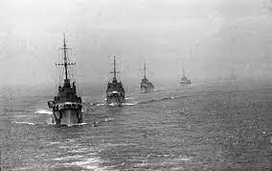
Arctic Convoy sailing
By early February 1942 , 12 convoys including 93 ships, had made it to North Russian
ports with the loss of one ship to a U-boat.
Things were to change after the Nazis failure on Russian soil. They started a systematic fight against the convoys which brought most of the aid to Russia. The Germans had the surface fleet and U-boats including the battleship Tirpitz lying waiting in a fiord
2 heavy cruisers, 10 destroyers , many submarines plus 260 Luftwaffe aircraft. All of these armaments would be used in concert as the allied convoys struggled in mountainous seas and ice flows in sub-zero temperatures .
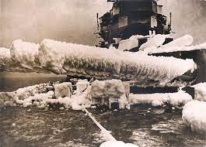
Frozen guns – Arctic Convoy
This was a frozen watery hell which took many’ s a good man to its bosom.
The telling of this story is pertinent in that my father joined HMS Britomart , a Halcyon Class minesweeper two months after the PQ17 convoy left for North Russia on exactly the same mission to bring much needed aid to Soviet ports of Murmansk and Archangel.

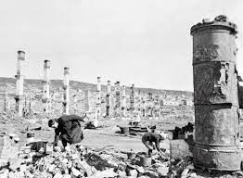
Murmansk in ruins (1942)

Gathering all the elements of this convoy in Iceland, it set out on 27 June 1942 for Archangel, probably the largest convoy so far, consisting of 35 merchant ship and a powerful close escort of 6 destroyers, 13 cruisers and one aircraft carrier. This was the first Anglo-American naval operation in this theatre of war ( post US lend lease ) and this decision contributed to the fate of this convoy ( see later ). The convoy, in sailing from Iceland, would maintain a more northerly course to northern Norway and Russia, in the hope of mitigating the chances of detection by German defences, which were strongly placed in the fiords along the length of western Norway.

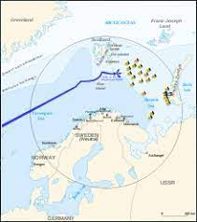
The convoy was located by the Germans on the 1 July and shadowed continually thereafter. They had various means of detection including spotter planes which scoured the length and breadth of the Norwegian coast. From his base in the Admiralty building in London,
First Sea Lord Admiral Pound received intelligence that German ships, including the great battleship Tirpitz , was moving to intercept . This was when wrong and momentous decisions were taken by both sides .

The Enigma

The Enigma machine was first invented by a German scientist in 1918, initially to maintain secrets in the commercial world but later it was adopted by the German armed forces where secrecy was deemed paramount in many situations.
By 1932 a Polish encryptor, helped by French intelligence persons, was credited with ‘breaking’ this early version of Germany’s secret code. Poland shared their achievements with the Western Allies and of course we all know of the valuable work done at Bletchley Park ,
in particular Alan Turing and his colleagues in Hut 5 . This highly secret operation ran from 1939 until 1946 .

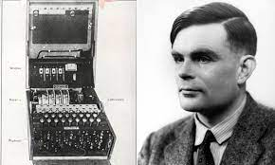
Alan Turing & his invention
A version of the Nazi naval enigma was worked on as the results would be of immediate value to the Allied navies. It was said that by breaking Enigma it shortened WW2 by 2 to 4 years. Originally the Enigma machine had three rotors to scramble the letters ( possibly the one the Poles worked on in 1932 ) but by 1941 at the height of the war,the Germans suspected that some of their encrypted messages were being ‘read’ by their enemies.
By early 1941 , the new version of the Enigma machine now had four rotors and new code books. This was a disastrous situation for former allied code breakers . Whereas in the past the German messages could be decoded in one of the large allied battleships and relayed to all of the ships in the convoy by morse code, now they were at sea without critical information of where enemy ships were ( especially U-boats ) in the highly defended seas around Norway and the north coast of Russia .

PQ17 convoy

﻿What follows was the Battle of the Arctic between the ships of the British-US convoy PQ 17 and the armed response of German warships and aircraft.
The allied convoy making for the north Russian ports consisted of 35 merchant vessels fully loaded with essential armaments, engine parts and foodstuffs for the Russian forces and people.
The convoy had a strong escort of 6 destroyers, 6 battleships, 13 cruisers,2 aircraft carriers and various minesweepers. In charge of the whole convoy was the British Admiral Tovey .
This was the first U.K./ US convoy in support of Russia. Germany responded with one battleship, 3 cruisers, 11 U-boats, 33 torpedo aircraft and 6 bombers ( flying over 200 sorties ).
In charge of the German forces were Grosse Admiral Raeder and Admiral Donitz, who took over the Reich after Hitler’s suicide . What followed was the misinterpretation of signals on the parts of both sides and the disastrous decisions that were to follow.
On the fourth day after leaving Iceland the convoy, German planes and submarines were monitoring its progress towards the Norwegian coast . Intelligence received by the Admiralty in London stated that the German capital ship Tirpitz was on the move, leaving its concealment in the fiord where it had lain at anchor, and moving out to meet the convoy in open seas.
The First Sea Lord in London was in contact with ships of the convoy’s close escort that the Tirpitz was moving out to do battle . This massive battleship was 45,000 tons and had formidable guns. Before this prized warship could leave the fiord, permission had to be sought from Hitler himself and this was granted .
However the Tirpitz remained in the fiord possibly because they felt it might receive much attention from the fleet of Allied warships. The First Sea Lord, acting on earlier information , and having given a number of warnings, ordered that all naval escorts move westwards away from the merchant ships thereby leaving the convoy totally on their own with absolutely no protection from the German battle fleet. It has been suggested that since US ships were in this convoy, they did not want the Tirpitz destroying US battleships in this their first outing - not so soon after lend and lease.

When the Admiralty ordered the convoy to scatter, the merchant ships were strung out over a few miles in open and hostile Arctic seas without any means of protecting themselves against the formidable German forces. This was a ‘turkey shoot’ for the U-boats, the torpedo aircraft and the ever present bombers.

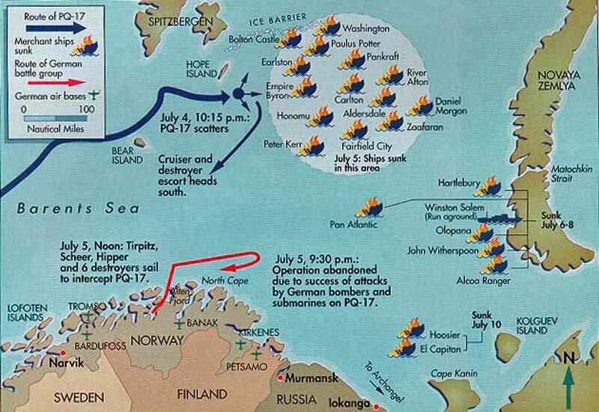

This was the worst naval disaster of the Allies during all of WW2. The inevitable enquiry into these matters was ordered by the First Sea Lord, Sir Dudley Pound , who had given the order himself for the convoy “to scatter”, the enquiry came to no conclusions as the top man couldn’t blame himself.
There followed attempts by some returning escort ship to search for survivors but there was little chance of doing so with the terrible Arctic conditions . Of those mentioned, the HMS Salamander, HMS Tuscaloosa ( both of which my father served on for short spells ) and the HMS Britomart which he served on for the next two years.
I am surprised that this inglorious episode ever reached the light of day , it’s secrecy being protected by a 50 year rule. With Alan Turing and colleagues at Bletchley Park deciphering the latest version of the Enigma Code, the future convoys and indeed the future of the war were now almost certainly assured in favour of the Allies.
Shortly afterwards, my father joined the Britomart on the 26 August 1942 for the next two years alongside the flotillas of minesweepers in the Arctic and sometimes in other locations. The Britomart would join the likes of sister ships, Salamander and Tuscaloosa in escort and minesweeping duties.
We will see what lay ahead for my father and fellow seamen from that time until the war ended three years hence.

Robert Newton Able Seaman RNR

Robert Newton enlisted in the Royal Navy in 1941 as an able seaman ( AB ) on the HMS Britomart and remained in the Navy for two and a half years, during my father’s time on the Britomart.
Before joining the navy, Newton had a successful career as an actor on stage and film from the early 1920s. He appeared with Laurence Olivier in ‘Hamlet’ in the West End in 1939.
After leaving the RN in 1944,Newton had his major break in the popular play ‘ This Happy Breed’ and also in 1944 he starred in Olivier’s version of ‘Henry V’. He was one of the most popular U.K. film stars of 1944.
However, he is best remembered ( even by some today ) in the lead role as the pirate in the film ‘Treasure Island’ , Long John Silver . This was the Disney British adaptation of RL Stevenson’s exciting adventure of the same name. Phrases like “Aye, Jim Lad” or “Pieces of Eight” became common parlance among the film cognoscente.
This film became the standard portrayal of pirates for years to come. This allowed him to reprise his pirate character in the film ‘ Blackbeard’ later in 1952. His fevered eyes and West Country ‘burr’ ( he came from Dorset) and his exaggeration of the West Country accent became the template for the popular pirate voice .

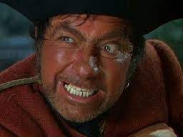

Robert Newton as Long John Silver

Newton began his acting career at the Birmingham Rep. at the age of 16. In 1937 he had small roles in cinema films under contract to Alexander Korda. He was borrowed by 20th Century Fox , and made films for Charles Laughton, Alfred Hitchcock and David Lean. He was rated highly with top directors during this period.
In the years 1940-1942 he was very busy in the West End, playing opposite the likes of Deborah Kerr, James Mason and Anna Neagle .
In 1948 his Hollywood career resumed in a film alongside Joan Fontaine and Burt Lancaster. In 1950 he appeared in the film ‘Waterfront’ in which a young Richard Burton appeared in his first film. Newton’s last theatre appearance was in a 1950 production of ‘Gaslight’ opposite Rosamund John at the Vaudeville Theatre.
His appearance in ‘Treasure Island’ prompted Newton to return to Hollywood in the film ‘Soldier’s Three’ . His last screen appearance was in the Oscar winning film ‘Around the World in 80 Days’ in 1956 opposite David Niven and Shirley MacLaine.
Newton was married four times and had three children. He was always a heavy drinker which possibly accounts for his early release from the RN . His chronic alcoholism quickened his death in 1956, at the age of 50 .
RIP Long John Silver.
My father must have met Robert Newton without knowing anything about his career as an actor. My father was brought up in a thatched black house and there was no cinema in Stornoway.

The Journeys of HMS Britomart

- ﻿Aug 1939. HMS Britomart was a newly built ship of the RN and was commissioned for service in the Ist Minesweeping Flotilla and was prepared for war operations. Acceptance by the navy after trials at Davenport.

- 26 Aug ‘39 joined the other six minesweepers of the Halcyon Class at Scapa Flow to ensure clear passage of the Home Fleet in and out of Fleet anchorage. Britomart was fully deployed in Oct ‘39 at Scapa Flow.

- Nov ‘39 the large battleship Royal Oak was attacked and sunk by a German U-boat who cleverly found the only way in past the large defensive structures in the Voe. 850 British seamen were lost.
After this, the flotilla was moved to the Clyde and all major ships of the Home Fleet were moved to safety in anchorage along the West coast of Scotland, pending
improvements of anti-submarine defences at Scapa Flow and the new fleet anchorages.

- Dec ‘39. Britomart resumed minesweeping in North Sea
service to ensure passage through the East Coast was clear of enemy mines.
By this time magnetic mines were being used extensively by the enemy in the North Sea.
1940
- Jan ‘40. Britomart transferred with the 1st Flotilla for Atlantic convoy defence based in Stornoway for escort of convoys during passage to Canada.

- Feb ‘40 Ship continued Atlantic convoy defence.

- Mar ‘40 and Apr ‘40 Britomart travelled to Leith for a refit along with HMS Bramble.

- May ‘40 Because of this refit Britomart was not deployed for the evacuation of allied troops from Dunkirk.
NOTE. The entire 51st Division of the British Army was captured by the Germans. Archie MacIver ( 10 Dalmore ) of the Cameron Highlanders spent five years in a German prison camp.

- Jun ‘40 to Dec ‘40. post refit trials , Britomart re-joined Flotilla at Scapa Flow for minesweeping.

1941
- Jan ‘41 and Feb ‘41. Still on minesweeping at Scapa Flow but nominated for transfer to Harwich.

- Mar ‘41 With 3 other minesweepers, deployed to clear mines in North East Command to ensure safe passage of the East Coast and for Channel convoys.
The Britomart came under enemy air attack during operation off Rye, Sussex and was hit by a bomb which exploded near the ship’s Wardroom killing all personnel within. However the damage sustained did not prevent the Britomart reaching Portsmouth under it’s own steam .

- Apr and May ‘41. Under repairs at Portsmouth.

- Jun’41 to Aug ‘41 Britomart resumed operational service with two other minesweepers, deployed for local escort of Atlantic convoys based at Stornoway .

- Aug ‘41 . Britomart nominated for detached service in North Russia for minesweeping operations. This was to ensure safe passage of Russian convoys to and from Iceland. The full flotilla of seven minesweepers was detailed for these operations.

- 11 Oct ‘41. Arrived in Archangel with convoy PQ1 And commenced minesweeping in North Russian seas.

- Nov/ Dec ‘41. Commenced minesweeping ops in the Barents Sea to ensure safe passage of traffic to and from Murmansk and Archangel.
1942
- Jan ‘42 continued sweeping operations in North Russia.

- 7 Feb ‘42. Joined inward joint Russian convoy PQ 9/10 as a local escort with HMS Sharpshooter.

- 10 Feb ‘42 . Detached from PQ 9/10 on arrival at Murmansk.

- 13 Feb ‘42. Joined return convoy QP7 to the U.K. for local escort during passage in the Barents Sea with HMS Sharpshooter.

- 15 Feb ‘42. Both minesweepers detach from QP7 and returned to Murmansk.

- Mar ‘42. Continued deployment in North Russia and nominated for return to U.K.
- Mar 21 ‘42 . Joined ocean escort for return convoy QP 9 at Kola Island with Sharpshooter.

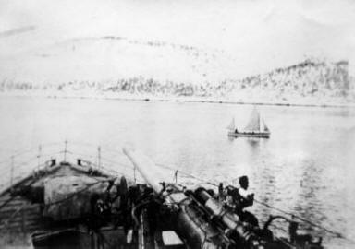
Kola Bay 1942 from HMS Britomart
- 3 Apr ‘42. Detached from QP9 on arrival in Reykjavik and took passage for return to the U.K.
HMS Britomart taken for repairs and leave commenced on arrival for ship’s personnel.

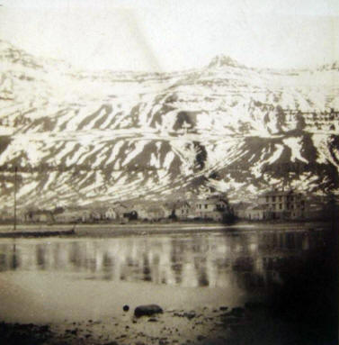
'Reykjavik (Iceland) April 1942

- June ‘42. After refit and trials Britomart took passage to Iceland to resume duties in North Russia.
- 27 June ‘42 . Joined escort for Russian convoy PQ 17 with minesweeper HMS Salamander.
NOTE. Convoy PQ17 had a large well armed escort consisting of two AA Auxiliary ships, and the destroyers Fury,Keppel,Leamington,Ledbury,Offa and Wilton , four corvettes and four armed trawlers.
- 4 July ‘42. Convoy PQ 17 was ordered to scatter by the Admiralty. This I’ll judged and disastrous decision is fully discussed in an earlier report.
- 5 July ‘42. Ordered to search for scattered merchant vessels of PQ17.
- 11 July’42. Arrived at Archangel escorting some of the ships of convoy PQ17 and survivors from the sea or in small boats. Resumed minesweeping duties in the Barents Sea.

My father joins HMS Britomart

The next part will see my father join HMS Britomart on 26 August, 1942 . The preceding parts on the Britomart were included to show the actions which my father could expect on a British minesweeper in convoy in the Atlantic and the Russian seas .
The naval activities during these times have been recognised as the most dangerous during WW2.

My father joined HMS Britomart on 26 August ‘42. The Britomart was at that time minesweeping in North Russia !! The question must be asked - how did he manage to get to N. Russia to join the ship ? I can only suggest that he got to N. Russia on an incoming convoy.
During its recent refit , the Britomart was fitted with Radar Type 271 , presumably its most recent development. The radar could detect a surfaced U-boat at 3500 yards distance, even if only its periscope was showing.
ASDlC ( British version of Sonar ) was fitted to smaller vessels to detect submerged
U-boats . Britomart would have Asdic already fitted.

My father joined minesweeper HMS Britomart on 26 August 1942 and would be with this vessel for two years mainly on convoy duties to and from North Russia.
NOTE . The previous articles on Britomart were to suggest the history of this ship and the conditions and dangers it might expect during convoy duties, in passage to the North Russian ports. These were the most dangerous voyages by sea in any war theatre during WW2.

The Arctic Journeys of Alexander Maclennan AB

- 13 Sept ‘42. Britomart is part of the Local Escort for return convoy QP 14 with HM Minesweepers Halcyon, Hazard and Salamander.
Note. This convoy was taking some of the survivors from PQ17 back to the U.K. and had a particularly strong Ocean Escort provided by the Home Fleet.

- 18 Sept ‘42. Britomart joined two Soviet destroyers in escort of inward Russian convoy PQ18 in the Barents Sea with the Local Escort of QP14 . During this time they were under German air attack.

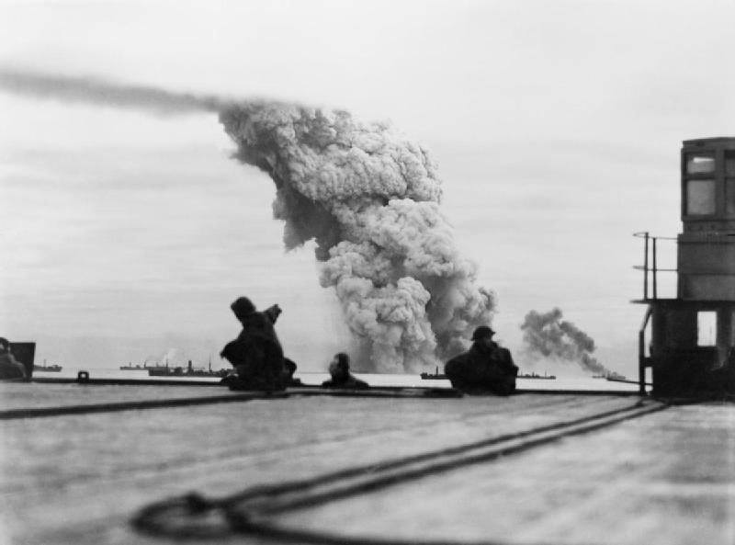
Daylight attacks on PQ18 from HMS Avenger's flight deck

- Oct ‘42 . Deployed in N. Russian waters minesweeping.

- 17 Nov ‘42. Deployed with minesweepers Halcyon, Hazard, Salamander and Sharpshooter from Archangel during passage in the Barents Sea of Convoy QP 15 to Loch Ewe .

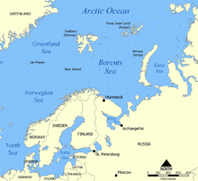
Map of the Barents Sea

- 20 Nov ‘42. Detached from QP15 and returned to Archangel with local escort.
- Dec ‘42. Britomart continues minesweeping in North Russian waters.

1943
Note. PQ notation changed in the meantime to JW .

- Jan ‘43. Nominated for escort of Russian convoy JW 52 and took passage to join this inward passage to Loch Ewe .

- 17 Jan ‘43. Deployed with HM Corvettes Lotus and Starwort and three trawlers as part of Ocean Escort for Convoy JW 52 from Loch Ewe.

Note . Fighting Escort of seven Home Fleet destroyers joined convoy on 21 Jan ‘43 and Distant Cover was provided by Home Fleet.

- 24 Jan ‘43. Convoy under air attacks but were ineffective .

- 27 Jan ‘43. Detached from Convoy JW 52 on arrival at Kola Inlet and resumed local minesweeping duties in N Russian seas.
Note. Sea going trawlers were commissioned by the Royal Navy, modified and armed to join the regular minesweepers .

- 26 Feb ‘43. Britomart in N Russia for minesweeping and patrol duties. Joined inward Russian convoy JW 53 as local escort for passage to Kola Inlet with five Soviet destroyers.

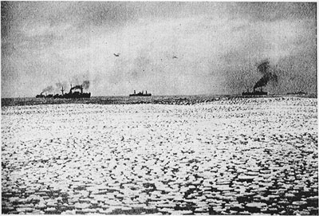
Convoy JW 53 passing through pack ice on passage to North Russia, February 1943

- 27 Feb ‘43. Detached from Convoy JW53 and resumes local minesweeping.
Mar ‘43. Britomart resumes minesweeping duties.
( Note. Russian convoys from U.K. were suspended due to need for escort to defend Atlantic traffic.)
- Apr - May ‘43. Britomart continued minesweeping and patrol in N Russia.

- 17 June ‘43 . Deployed with HMS Jason as escort during Russian icebreakers.

- 22 June ‘43. Britomart and Jason detached from icebreakers on arrival in Kara Sea and returned to Kola Inlet.

- July - Sept ‘43. In this period while minesweeping off Cape Artica
we came under air attack and hit by two bombs which were deflected off Britomart’s deck without exploding.

Note. Along with Britomart, other minesweepers operating in N Russia were HM Jason, Hazard, Halcyon, Gossamer and Sharpshooter in Sept ‘43.

- Oct ‘43 . Nominated for return to U.K. with HMS Jason. Prepared for return passage.
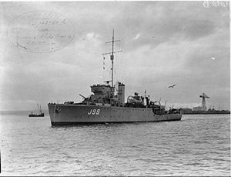
The Troon-built HMS Jason

- 1 Nov ‘43. Joined return convoy RA54A at Kola Inlet as part of Ocean Escort with
HMS Jason , HM Norwegian Corvette SOROY and nine Home Fleet destroyers.

- 14 Nov ‘43. Detached from convoy RA 54 A on arrival at Loch Ewe after an uninterrupted passage. Britomart sent for refit and leave for ship’s company.
- December’43. Britomart under refit.
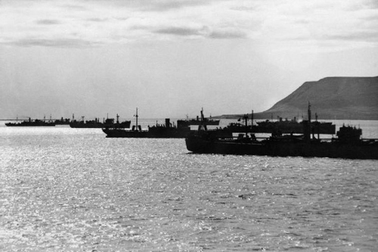
A convoy assembling Loch Ewe
1944
- Jan ‘44. Britomart nominated for service with newly formed 1st Minesweeping Flotilla. Ships in the Flotilla were HM Minesweepers Britomart, Harrier,Gleaner, Halcyon, Hussar,Salamander,Seagull and Speedwell. On completion of trials, Flotilla carried out a work-up exercise.

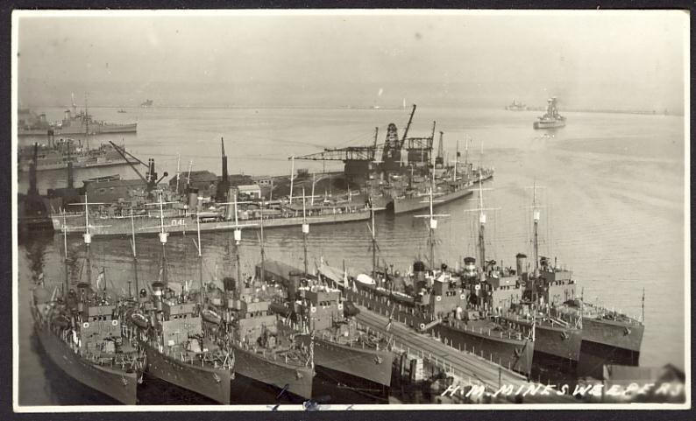

Minesweeping Flotilla at Portland
- Feb to Mar ‘44. Britomart deployed for exercises minesweeping in North Sea with Flotilla. Britomart nominated for minesweeping support during planned Allied landings in Normandy
( Operation NEPTUNE i.e. D-DAY ).

- Apr ‘44. Britomart took passage to Portsmouth to join Force S.

- May ‘44. Nominated with Flotilla for mine clearance of approach channels to the beachhead anchorage areas.
(Note: Three motor launches and four Danlayers were attached to the Flotilla for this specialised operation ). A Dan-layer was usually a converted trawler which lay buoys or other markers to show which areas had been cleared of mines after minesweepers had passed.

- May (cont ). Britomart took part in preparatory exercises with ships of Force S
( Exercise Fabius ) and carried out night-sweeping in preparation for D-DAY.

- 4 June ‘44. Deployed at Portsmouth for briefing and preparation for minesweeping of Channel 9 in advance of Assault Convoy.

- 4June ‘44. Operation delayed for 24 hours due to weather.

- 5 June ‘44. Sailed from Solent to commence channel 9 clearance.

- 6 June ‘44 ( D-Day +1 )
On completion of Channel 9, deployed for minesweeping of anchorage sites.

- 8 June ‘44. Deployed for minesweeping approach channels and patrolling areas off Eastern Task Force landing areas.

- July ‘44. Channel minesweeping and convoy defence continues. Under threat of attack by German E-boats ( very fast launches, and highly armed ) and also midget submarines.

- Aug ‘44. Channel minesweeping continued off Arromanche with HM minesweeper’s Britomart, Harrier, Jason, Hussar, Gleaner and Salamander.

- 17 Aug ‘44. My father was transferred from HM Britomart to U.K. home base.

- 22 Aug ‘44. Britomart was transferred to the coastal area of Le Havre ( still in German possession ) for minesweeping in an anchorage selected for bombardment of enemy positions by HM Battleship Warspite and monitors Erebus and Roberts.

- 23 Aug ‘44. Minesweepers in Seine Estuary under fire from enemy shore batteries.

- 26 Aug ‘44. Permission for Flotilla to remain minesweeping in the Seine Estuary instead of taking passage to Arromanche approved in order to complete mine clearance.

- 27 Aug ‘44. During final clearance of this area , the Minesweeper Flotilla came under sustained attack from the air , not from the Luftwaffe , of course, as the entire German air force had by now been destroyed, but by ‘ friendly fire’ , the ironic phrase used by armed forces when one kills one’s own soldiers.

The Sinking of HMS Britomart

This part concerns the demise of HMS Britomart and other minesweepers while sweeping in the English Channel in connection with the Normandy Landings by the Allied Forces.
The Allies had fighter aircraft at an airfield near Caen southwest of the Seine estuary where the No.1 Minesweeping Force had been preparing channels for the entry of a British destroyer, deployed to attack Le Havre ,still in German hands.
Suddenly and without warning a large number of fighter aircraft descended from a great height at speed and with sun at their backs , machine gun and rocket fire raining down on the unfortunate Royal Naval minesweepers.
HMS Britomart sank and other vessels of the Flotilla either sank or were badly damaged. In modem parlance this was an example of ‘friendly fire’ delivered by 16 RAF Typhoon fighters and 12 Spitfires of a Polish Squadron. The attack took place off Cap d’ Antifer , near Le Havre. 78 officers and ratings were killed and 149 wounded, many grievously.

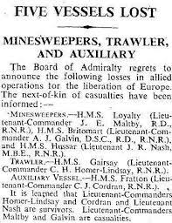
Contemporary news report on the sinking of HMS Britomart
At the inquest which followed it transpired that everyone was informed by the Navy of why and where the minesweepers were sweeping off the Seine close to Le Havre . Everyone was obviously informed except the RAF and this large flotilla sailing so close to coastal waters off Le Havre was taken to be enemy ships.
At first this grievous error was blamed on the RAF, but very soon the blame came to lie with the Navy itself . Of course the disaster was hushed up with nothing in the newspapers nor on the radio. Officers of the Navy and RAF were told that the tragic blunder was due to ‘ an error of communication ‘.
Three Naval Officers were court marshalled .
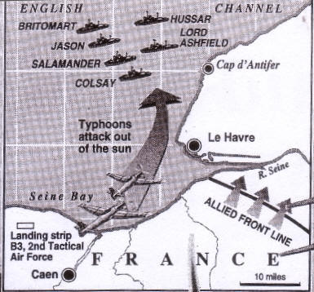
Illustration from Daily Telegraph
HMS Britomart obviously played no further part in WW2 . My father moved on within the RN , obviously unaware of what happened on that Bloody Sunday 27 August 1944, ten days after been posted to shore leave.

“In Appreciation:
The War Cabinet fully appreciates that , but for the courage, skill and devotion of
HM Minesweeping Forces ,
the success of the recent amphibious operations, and especially of the landings in
Normandy could not have been achieved without them.”
Winston Churchill .

The Big Picture
The presence of an extensive German minefield running along the Channel presented a significant challenge of the Naval Assault Forces reaching the Normandy beaches in good order. 255 minesweepers were to cut ten channels through the minefield for the initial Assault Force. The minesweepers had to widen the channels and clear areas off shore for ships to collect.
These were very dangerous procedures under constant German assault.
About 550 mines were accounted for during June in the Eastern Force Area alone.
We will follow the remainder of my father’s time in the Navy , just over a year in all and mainly in U.K. Home Bases. He had fought the good fight in dangerous theatres of war and was fortunate to make it through unscathed unlike others.

HMS Drake

HMS Drake was a U.K. shore establishment in S.England which has increased enormously to become HM Naval Base ( HMNB ) Devonport and is now the largest naval base in Europe.
From 1937 to the early 21st century the name HMS Drake referred only to the naval barracks within the base.

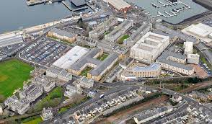
HMS Drake 2015
After leaving the Britomart on 17 August 1944 , my father was at HMS Drake on three separate occasions
- 18 Aug ‘44 - 5 Nov ‘44
- 27 Mar ‘45 - 20 Apr ‘45
- 01 July ‘45 - 16 Oct ‘45 .
In 16 Oct 1945 my father finally left the Royal Navy and was demobilised into civvy street.
The final two ship/ shore establishments which appear on Alex Maclennan’s
service history were :
( a ) HMS Foliot IV , a shore based training course.
There were three other ‘Foliots’ numbered I , II and III. Foliot IV ran from 6 Nov ‘ 44 until 26 Mar ‘45.

It involved U.K. Land Based Combined Operations and further training of formed flotillas ( eg minesweepers ) was carried out at a Land Base.
( b ) HMS Searcher. 23 Apr ‘45 until 30 Jun ‘45. ( a mere nine weeks).
In the short time he was a crew member of the Searcher, nothing of note occurred according to the ship’s history , but before and after this period, Searcher was in action in U.K. waters and later off in Norway.
HMS Searcher was an escort aircraft carrier built in the USA . It had a complement of 650 men. Launched in 20 Jun ‘42, she was commissioned into the RN in 7 Apr ‘43 ( lend - lease ).
From that time it operated mainly in U.K. waters as a fighter carrier which held 20
planes on its flight deck.

In late Dec ‘43 Searcher provided Atlantic convoy escort , escorting ships to
Norfolk, Virginia. Later she was moved to Norwegian waters where she participated in attacks on
the German battleship Tirpitz as part of the U.K. Home Fleet, providing fighter cover.
The Tirpitz, a giant battleship located for some time languishing in the Kaafjord,
was attacked many times from September 1943 until finally on 15 Sept ‘44 she was attacked by 21 RAF heavy bombers disabling the Great Tirpitz , the final insult coming from explosives attached to a midget submarine.
It seems my father missed quite a show in that fiord. He was well away from there and thankful, I guess.

“Boxing the Compass “

This final section is a homage to my father, Seaman RNR, during 17 years in the Merchant Navy followed by 6 years in the Royal Navy during WW2 .
In both navies,his experience and knowledge as a quartermaster would be called on many times during peacetime and the hell of war.
My father and I would sit by the fire, and he would regale me of his life at sea . This would only take place when we had the house to ourselves .
As the helmsman on the bridge of a ship, he required to know compass bearings whether in the traditional manner ( N,S,E,W etc ) or as a 3-figure bearing ( 0 to 360 degree ).
Whether the direction was quoted as a 3-figure bearing (eg. 185 degrees) or using the traditional directions ( eg. SW ) each was related to Magnetic North ie. N or 000 degrees and other bearings achieved by rotating clockwise from North . They are related as follows.
North. <———>000 deg
East. <———>090 deg
South. <———>180 deg
West. <———>270 deg
and points In between.
In his early career he would be familiar with the traditional bearings, and they were committed to memory by “boxing the compass” , literally as a sort of rhyme. e.g.
N , NbE , NNE ,NEbN, NE
travelling clockwise from N .
‘b’ stands for ‘by’ indicating clockwise.
You have ‘boxed’ part of the circle from N to NE . In doing so you have covered 4 compass intervals i.e.
N - NbE - NNE - NEbN - NE
( 1 ). ( 2 ). ( 3 ) ( 4 )
through the relevant compass points. Further clockwise turning takes us from NE towards E. ie
NE - NEbE - ENE - EbN - E
Together we have covered 8 compass points in one quarter turn, and obviously there are 32 points in a full clockwise rotation. These are the 32 points which all helmsmen must know by heart when “boxing the compass “.
For interest, boxing further
from E to S we get
E- EbS- ESE- SEbE- SE-SEbS- SSE- SbE- S
Boxing further through the next half turn from S through W to N again. These are the 32 points used mostly in plotting a ships course.

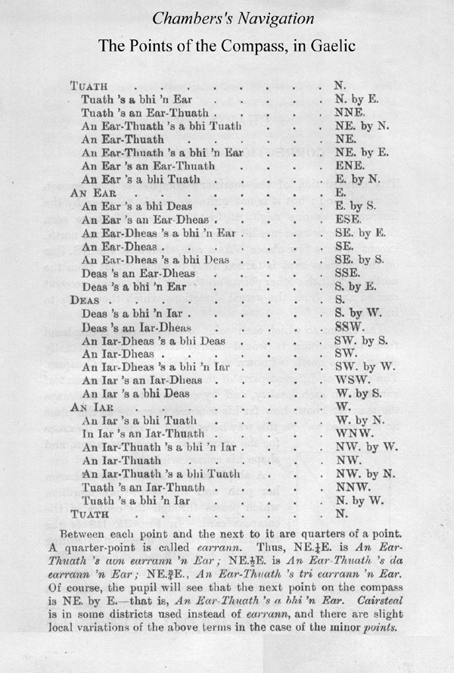
For finer courses, the above compass interval could be divided into 4 “quarter points”
e.g.
N, N1/4E,N1/2E,N3/4E,NbE
More in theory than in practice, I think !

Under my father’s tutelage I learned to box the compass forward and backwards .
Even in the early 1920s my father’s experience as a ship’s quartermaster would certainly have used the traditional compass , but as his time at sea continued, more vessels had moved over to compasses giving directions as 3-figure bearings.
My father was au fait with either system, but he must have welcomed the simplicity of the numerical bearings over the strange directions like SEbS.
No need for my father and me to learn and practise the compass by ‘boxing’ it. Numbers replaced letters and mathematics won the day. My ability to box the compass is a beautiful thing my father left to me and I feel his presence when I’ve periodically ‘taken the mariner’s compass from its box’.
My father , at times told of his experiences in the Navy . He used to say that sea conditions during convoys were at times so bad that it was impossible to steer a ship by compass. All you could hope to do was to point the ‘ship’s nostrils’ directly into the mountainous waves and by holding onto the ship’s helm, never allowing the ship to stray to port or starboard .
There was no way back to the ship’s sinking . Sometimes the waves were so high that a large vessel could be stranded on the crest of a wave, only to fall into an abyss , breaking its back in the cruel sea.
Thankfully, you could steer by compass most of the time.
The seas west of Norway and in the Arctic oceans of North Russia were not only tempestuous but they, and the ambient air temperatures , were many degrees Celsius
below zero .

Ships sailing north in these waters and their crews were in permanent danger of dying , even without the sustained attack of German U-boats and bombers. The temperatures on deck were so low that everything there was covered in feet of ice , such that it had to be manually broken off to allow certain moving parts to function.
My father said that in these freezing conditions , he witnessed from the bridge of his ship a man on the foredeck being propelled overboard in the strangest manner. A hawser on deck was so frozen that it snapped, and like a giant whip, it carried the man to his hellish death.
Often on a minesweeper you were in the vanguard of a convoy, but even there my father could see merchant ships lying on the far edge of a convoy lighting up the sky in these dreadful and massive explosions . These ships went down with no survivors . My father said that your ship had to proceed, and you didn’t need to be told by the officer-of-the-watch.
These were the most dangerous seas on the face of the planet and many a brave seaman found his grave there.

On Guard Duty at Murmansk
Once, probably the only time, my father was chosen to be part of a RN guard party to be present at the unloading of a large U.K. merchant ship newly arrived in Murmansk, North Russia.
Everything from tanks and aircraft to machine parts and petroleum was carried to Russia in massive convoys by sea.
When cargo was off loaded onto Russian soil , the accepted practice was to rope off the area where the cargo would, as it were, move from U.K. territory to Russia.

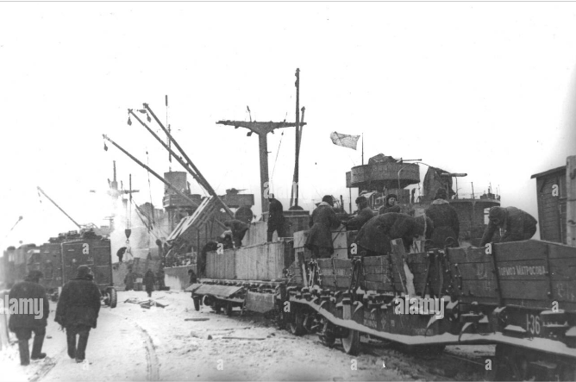
Unloading convoys in Russian Arctic
My father, wearing a white topped hat , white belt and ‘Spats’ and rifle in present- arms mode , lined up with the other ‘guards’ between the two white ropes designating British territory.
Very heavy wooden crates were uplifted by Russian women and carried , bent over, ‘ from Britain’ between the white ropes to Russia.
Just as a woman carrying a large box passed my father’s position , she stumbled and was persuaded to get up when a Russian guard pushed the butt of his gun into the women’s back. Whatever sign my father gave in response was picked up by his naval officer and very quietly told to ‘rest easy’.
My father from that day had no time for Russians, but fortunately he never met another Russian ( I think ).

Anecdotes

This post consists of four anecdotes told to me by my father by the fireside as usual , the first two when he was a Sailor AB in the Merchant Navy .
1. Monte Carlo
The following story took place on the Mediterranean coast of France possibly when he was cruising as a sailor on the vessel “Samaria” during September,1934 . He rarely signed up on cruise ships, but when needs must …... .
He would have been appalled at the cruise behemoths of today. The “ Samaria” was tied up and the rich passengers (and sailors ) given ‘leave’ to explore the coast of millionaires, artists and the beautiful people who walked the esplanades of the Riviera. My father and some buddies ended up in the casino at Monte Carlo , where for a small fee, you observe the gamblers from a gallery above the roulette and blackjack tables. This was where very rich people gambled against the house , where perhaps thousands of francs might be bet on the turn of a card.
My father and friends noticed this man across the way pacing back and forward for some minutes, then suddenly stop , pull out a revolver from his coat and shot himself through the temple . The dead man had been playing a very risqué form of dice called ‘Crown and Anchor’, where in this famous casino there were no limits to bets. The man , it seems, lost a fortune in money, houses and estates. Suicide was not uncommon in this beautiful palace of giant mirrors and lead glass chandeliers.
I presume the sailors had a few whiskies after witnessing that poor man’s demise.
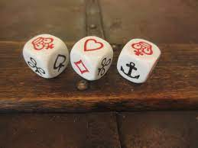
The fateful dice

2. A Life Changing Offer
In a long career in the Merchant Navy my father visited most corners of the earth and often in the North Pacific and Australasia. On this occasion his ship had been visiting bunkering ports in Australia and New Zealand and this evening his ship was tied up on a pier in Dunedin harbour. As the name suggests, the city of Dunedin was so called by the founding fathers , being the Gaelic for Edinburgh . South Island , New Zealand was back in time an attractive prospect for emigres from Scotland, especially those from the Highlands and Islands. This island’s weather and topography reminded the Scots of ‘home’ . Many Hebrideans and other Gaelic speakers found a new country, literally on the opposite side of the globe.
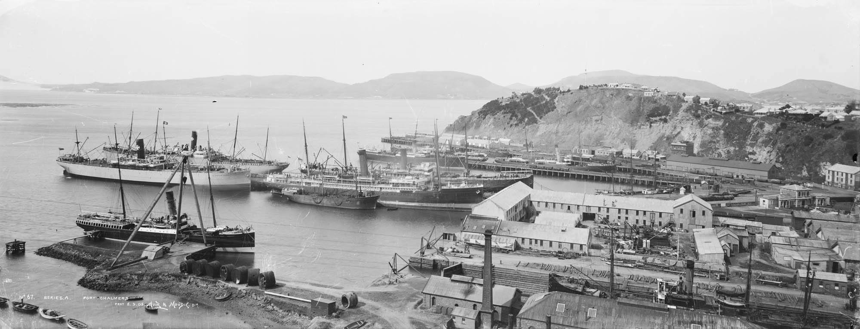
Dunedin Harbour
That night, probably smoking a cigarette, my father was leaning over the side of the ship when he saw this man walking across the pier heading towards him. It didn’t take long for them to realise that each of them hailed from the Isle of Lewis. He, the older man, said that he was the superintendent of the Dunedin Port Authority , having lived in the city for many years . He had high praise for Dunedin and its people and that a young man like my father would do well there. He never regretted his decision to emigrate to New Zealand all these years ago.
The man pointed out that since no one was here abouts , my father could easily and safely come over to the pier side and that he, the superintendent, would take care of everything including accommodation and because of his standing he could easily arrange papers of immigration .
My father said that he was tempted by the eulogy the man gave but that under the circumstances he could not accept the offer. He told the older Lewis man that he had left his sweetheart ( my mother ) back home in Dalmore.
I am very glad he made the right decision. Well, I would say that, of course.

3. The Battle of the River Plate
During 17 years in the merchant navy , my father had travelled far and wide including the South American countries of Argentina, Uruguay, Brazil and Chile. The cities of Buenos Aires and Montevideo on the River Plate were familiar to him.
It may have been that I discovered that the film ‘ The Battle of the River Plate’ , newly released in 1956 was showing at the La Scala Cinema in Paisley . We watched the film together and I could see that he was intrigued with the story involving real naval warships in the South Atlantic. He had served on cruisers and battleships but here was the chance of seeing these mighty warships on the screen up close . Aged 15 years it was unlikely that I had heard of the ‘Battle or the River Plate‘ , but I had the feeling that he had heard something about this battle. The German ‘ pocket’ battleship “ Admiral Graf Spee “, commissioned in 1936 ,tonnage 16,020 with a top speed of 32 and a formidable array of six 11 inch guns . Only a few allied ships were powerful enough or fast enough to sink these pocket battleships .
The Graf Spee had all of the South Atlantic as its ‘ play zone ‘and in the period September-December of 1940 July the warship sank nine allied merchant vessels of a total 50,090 tons. Although the allies had other naval commitments, they sent three cruisers to hunt down the Graf Spee ( HMS Achilles, Ajax and Exeter ) . They finally met in the broad estuary of the River Plate .
One British cruiser was so badly damaged that it pulled out of the fight . The Graf Spee was so badly damaged that it sought refuge in the neutral port of Montevideo but the authorities there would only allow 72 hours in port. Captain Hans Langsdorff decided to scuttle his ship in the bay off Montevideo.
Captain Langsdorff was a humane man . In many cases before he sank the merchant ships, he allowed their crews to launch the lifeboats and only when they were distant enough did he sink the ships. My father expressed admiration for the German captain for how he treated his prisoners. In a hotel room in Montevideo Langsdorff killed himself by shooting.
I think my father was right in his opinion of the captain of the Graf Spee

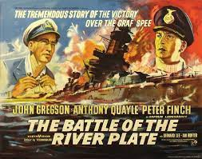

A poster for the 1956 movie that might’ve caught my father’s eye

4. “Ever been to Paraguay ?”
One evening in 1959 I was doing revision for my Higher Geography Exam in a few weeks hence . The revision topic was the geography of South America, and I was sitting at the large dining room table , covered in books, class notes and the obligatory maps of the continent of South America.
My father was asleep by the fire across the way . This was the man who ‘had sailed the Seven Seas’ and a few Oceans besides. He could recite all the places he had visited during his time in the Merchant Navy viz. Bunbury, Perth Australia, Montevideo, New York, Yokohama, Zanzibar and a hundred more ports around the world .
Now sitting there and glancing over at my well-travelled pater, I decided to put his geography to the test ( any son would do that ! )
Studying this land locked country, I asked him if he was ever in Paraguay in S. America.
“ Once” he said, “ I remember leaving Montevideo and sailing up the River Plate and a few rivers more , arriving in Asuncion , the capital of Paraguay”.
I was amazed at his answer which was correct of course and my admiration for my father was taken to an even higher level. He went back to sleep and I smiled to myself.
Asuncion is land locked but is navigable via the Rivers Plate, Parana and the River Paraguay. In case like me, you might have bet against Big Alex, I have saved you the time consulting a very large map.
Of course, if you were quartermaster on that ship, you would obviously remember how you sailed to the capital of Paraguay. Yes ?

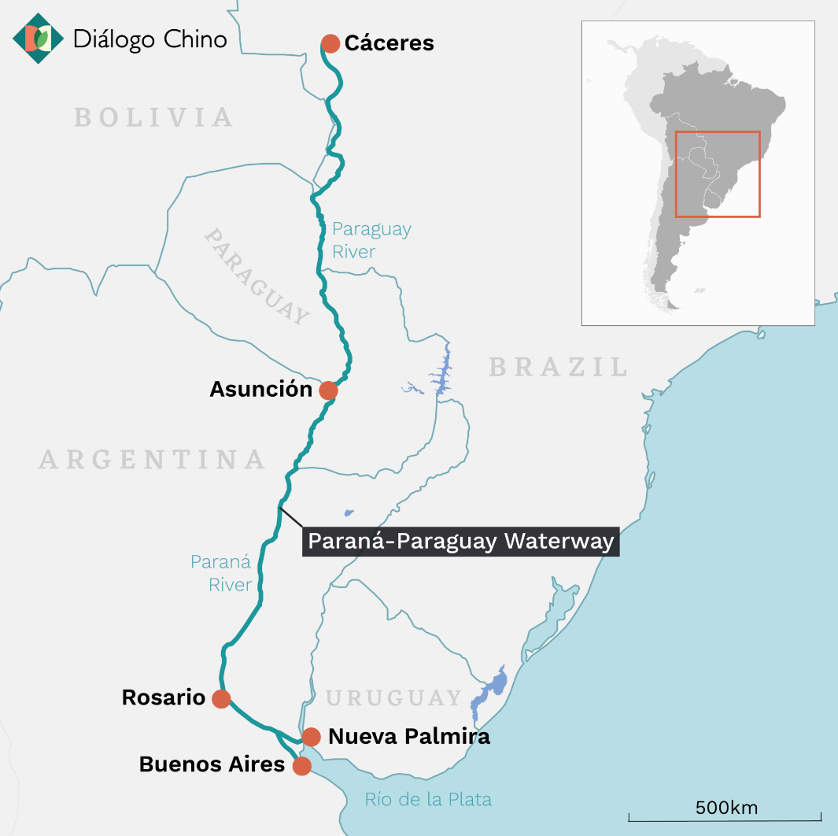
Proof indeed

God bless you, Father . I am proud of you now as I was that night in Ferguson Avenue.

Alexander Maclennan RNR

FINIS

(01/12/2023) .

The author would like to acknowledge the contributions made by Iain MacArthur of the Carloway Historical Society, his brother Gordon Maclennan & son Alasdair in the compilation of this document.
HOME AT LAST. MY FATHER IN DALMORE, IN A RELAXED MOOD, SHORTLY AFTER THE WAR ENDED

